Appendix B – Parental Consent Form

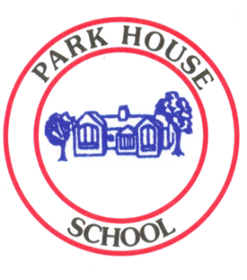
Park House Primary School
Rupert Street, Lower Pilsley,
Chesterfield, Derbyshire,
S45 8DB


Tel/Fax: 01246 851185
Headteacher: Mrs S Kavanagh @parkhouse1889

Parental agreement for school/setting to administer medicine

The school/setting will not give your child medicine unless you complete and sign this form, and the school/setting has a policy that the staff can administer medicine.

Name of school/setting | PARK HOUSE PRIMARY SCHOOL
Name of child
Date of birth
Group/class/form
Medical condition or illness
Medicine
Name/type of medicine
(as described on the container)
Dosage
Timing
Special precautions
Are there any side effects that the school/setting needs to know about?
Self-administration
Procedures to take in an emergency
Contact Details
Name
Daytime telephone no.
Relationship to child
Address

I understand that I must deliver the medicine personally to the class teacher. I accept that this is a service that the school/setting is not obliged to undertake. I understand that I must notify the school/setting of any changes in writing.

Signed…………………………………………………………………………..

Date…………………………………………………………

Appendix B – part 2

Date:
Time:
Dosage:
Name administering:

Date:
Time:
Dosage:
Name administering:

Date  written: |  | Dates reviewed:
Completed by: |  | Reviewed by:

Comments:

