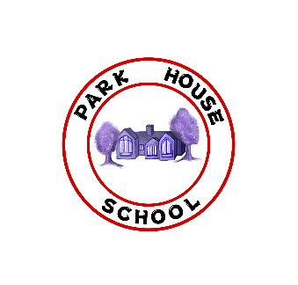**Park House Primary School**

**Specific Situation Privacy Notice Template**

Name of Event or Exercise

|  |  |
| --- | --- |
| Why do we need to collect personal data? | We want to |
| What will it be used for? |  |
| How long will we keep it? |  |
| How will we store it? |  |
| Will it be shared with others? If so, who? |  |
| What about your Data Protection rights? | For more information about how data is collected, stored, used and protected, please see our UK GDPR / Data Protection Policy which can be found on our website ADD LINK  You will find details about your rights and how to access data we hold, and what to do is you are not satisfied or wish to complain. |