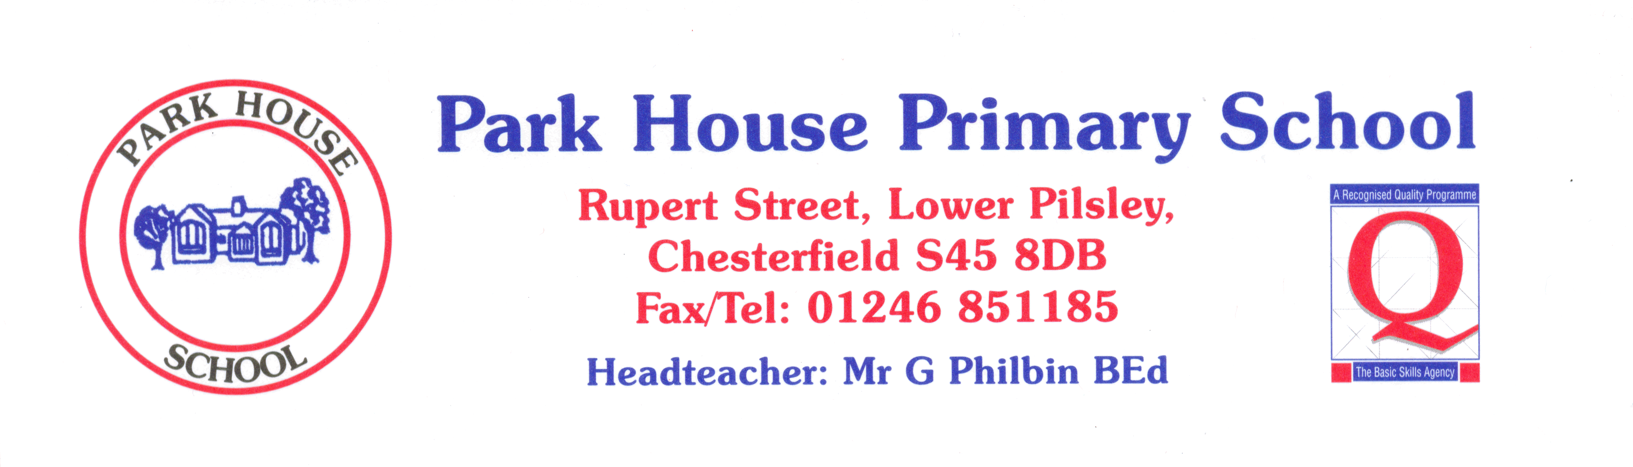

 | YEAR R | Always | Nearly always | Sometimes | Never
1 | I like coming to school. | 91 | 3 | 3 | 3
2 | I learn a lot in lessons. | 100
3 | My teachers help me to do the best I can. | 97 | 3
4 | I know how well I am doing at school. | 93 | 7
5 | Adults in school explain to me how to make my work better. | 90 | 3 | 7
6 | Teaching at our school is good. | 100
7 | Teachers help me to read, write, do my number work  and talk to others. | 97 | 3
8 | Behaviour is good in school. | 39 | 61
9 | Behaviour is good in lessons. | 61 | 39
10 | The teachers sort it out if somebody is being bullied. | 97 | 3
11 | I feel safe when I am in school. | 93 | 7
12 | Teachers are interested in what I think. | 97 | 3
13 | Teachers expect me to be responsible for my work in class. | 93 | 7

