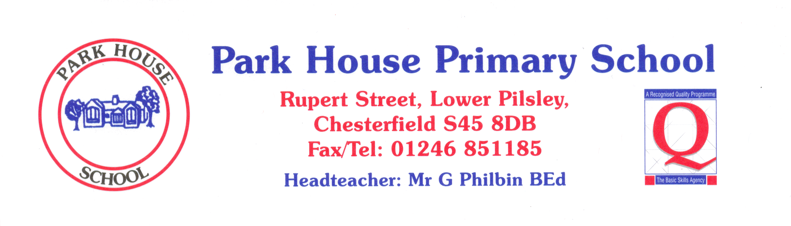

 | YEAR 5 | Always | Nearly always | Sometimes | Never
1 | I like coming to school. | 56 | 32 | 9 | 3
2 | I learn a lot in lessons. | 78 | 16 | 6
3 | My teachers help me to do the best I can. | 84 | 16
4 | I know how well I am doing at school. | 55 | 32 | 13
5 | Adults in school explain to me how to make my work better. | 87 | 10 | 3
6 | Teaching at our school is good. | 97 | 3
7 | Teachers help me to read, write, do my number work  and talk to others. | 75 | 16 | 6 | 3
8 | Behaviour is good in school. | 16 | 52 | 29 | 3
9 | Behaviour is good in lessons. | 29 | 45 | 26
10 | The teachers sort it out if somebody is being bullied. | 100
11 | I feel safe when I am in school. | 87 | 10 | 3
12 | Teachers are interested in what I think. | 81 | 10 | 9
13 | Teachers expect me to be responsible for my work in class. | 94 | 6

